Bahria University,
Karachi Campus


COURSE: CSC-110 COMPUTING FUNDAMENTALS
TERM: FALL 2022, CLASS: BSE- 1(B)

Submitted By:
02-131222-099
ABDULLAH
_______________________________________________
(Name) (Reg. No.)
Submitted To:

Engr. Rahemeen Khan

Signed Remarks: Score:

INDEX
SNO | DATE | LAB NO | LAB OBJECTIVE | SIGN
SNO | DATE | LAB NO | LAB OBJECTIVE | SIGN
Bahria University,
Karachi Campus


LAB EXPERIMENT NO.
01
_______
LIST OF TASKS
TASK NO | OBJECTIVE
01 | Design layouts for input output storage devices.
02 | To create an Advertisement.
03 | Draw a Pie Chart to show a percent of PC operating profit 2016 with a different color, design and percentage choice, Format data labels and legend labels.
04 | Draw a cycle process through word smart art which include your daily routine.
05 | Create a word document that include Biography, Best childhood memory, Inspiration, Favorite sports, Position in next 5 Years, Social Networking Sites/links.
06 | Apply Mail merge on a congratulations letter to the employee for getting new job. Add different fields and send it to friend

Submitted On:
/10/22
____________
(Date: DD/MM/YY)

Lab Tasks

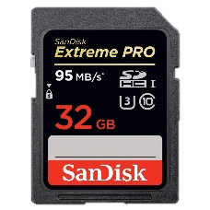
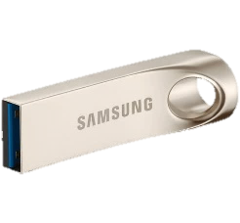
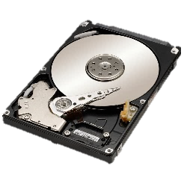
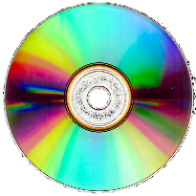
Task #01: Design layouts for input output storage devices.
Can you think of any other Storage devices?
SD Card
CD/DVD Drive
USB Drive

Hard Disk
Storage Devices are used to record (Store) data
Storage Devices
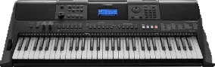
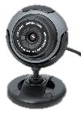
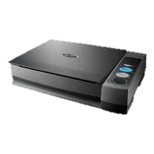
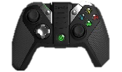
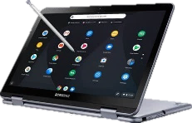
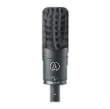
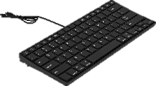
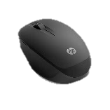
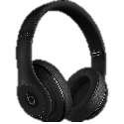
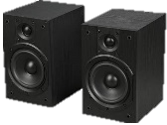
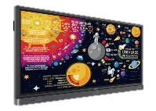
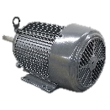
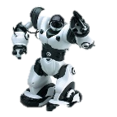
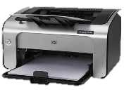
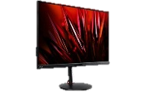
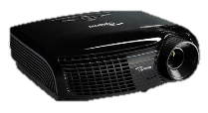
Musical Instruments
Webcams
Scanner
Game Controller
Touch Screens
Microphone
Keyboard
Mouse
Can you think of any other input Devices?
Input Devices
Input Devices send data and control signals to the computer.

Headphones
Speakers
Interactive Board
Motor
Can you think of any other Output Devices?
Robot
Printer
Projector
Monitor
Output devices communicate the results of proceeded data.
Output Devices

Task # 02: To create an Advertisement.
COMPUTER SLOW?

Task # 03: Draw a pie chart to show a percent of PC operating profit 2016 with a different color, design and percentage choice, Format data labels and legend labels.

http://www.trimegatech.com
Servicing Anne Arundel and Howard Country. We come to you.
410-280-1780
trimegatech
Network setup, new office setup, web design, web development, servers, etc.
For small mid-sized business
FREE CONSULATION
Take advantage of our grand opening 50% off sale. IT only happens once.

Anti-Virus/spyware removal, pc repair, backup wireless networks, hardware upgrade, vista, etc
All Services for home users
50% Off

We offer technology solutions and support for home users, home offices, and small-mid sized businesses.

Task # 04: Draw a Cycle Process through word smart art which include Daily Routine.

Task # 05: Create a word document that include following headings:
- My biography
- My best childhood memory
- My inspiration
- My favorite sports
- Where do I see myself in five years?
- My social Networking Sites/links
Solution:
- My Biography:
My name is Abdullah Sadiq. My father name is Muhammad Sadiq. I am 17 years old. I have passed 10th from E.A.B PN Secondary School Karachi. I have done my FSC from Bahria College NORE-1. I am studying Software Engineering at Bahria University Karachi. My home town is Faisalabad but I am currently living in Karachi. My hobby is Photography.
- My best childhood memory:
I still remember the day when I was 7 years old, my Father gifted me a Brand New Bicycle. I was so excited to ride it because it was a totally new experience for me. And this is one of the best childhood memory I can’t forget.
- My inspiration:
I am extremely inspired by my Father. My Father is an inspiration for me. Whenever I feel dull or depressed, I just think about the efforts he has done for us and he is still doing. He has taught me the toughest lessons of life. He is an ideal for me and I am nothing without my father.
- My favorite sports:
“Honesty is a great policy”. To be honest, I don’t have any interest in sports. But as we know “Healthy body has a healthy mind”. So, to maintain fitness I prefer running. I wake up early in the morning and start running.
- Where do I see myself in Five year:
After Five years, I see myself as a Skilled Software Developer performing his Best to Digitalize Pakistan and making every possible effort to represent Pakistan in a positive way.
- My Social Networking Sites:
All of my Social Media Handles:
Email
Facebook
Instagram

Task # 06: Apply mail merge on a letter.
Solution: 